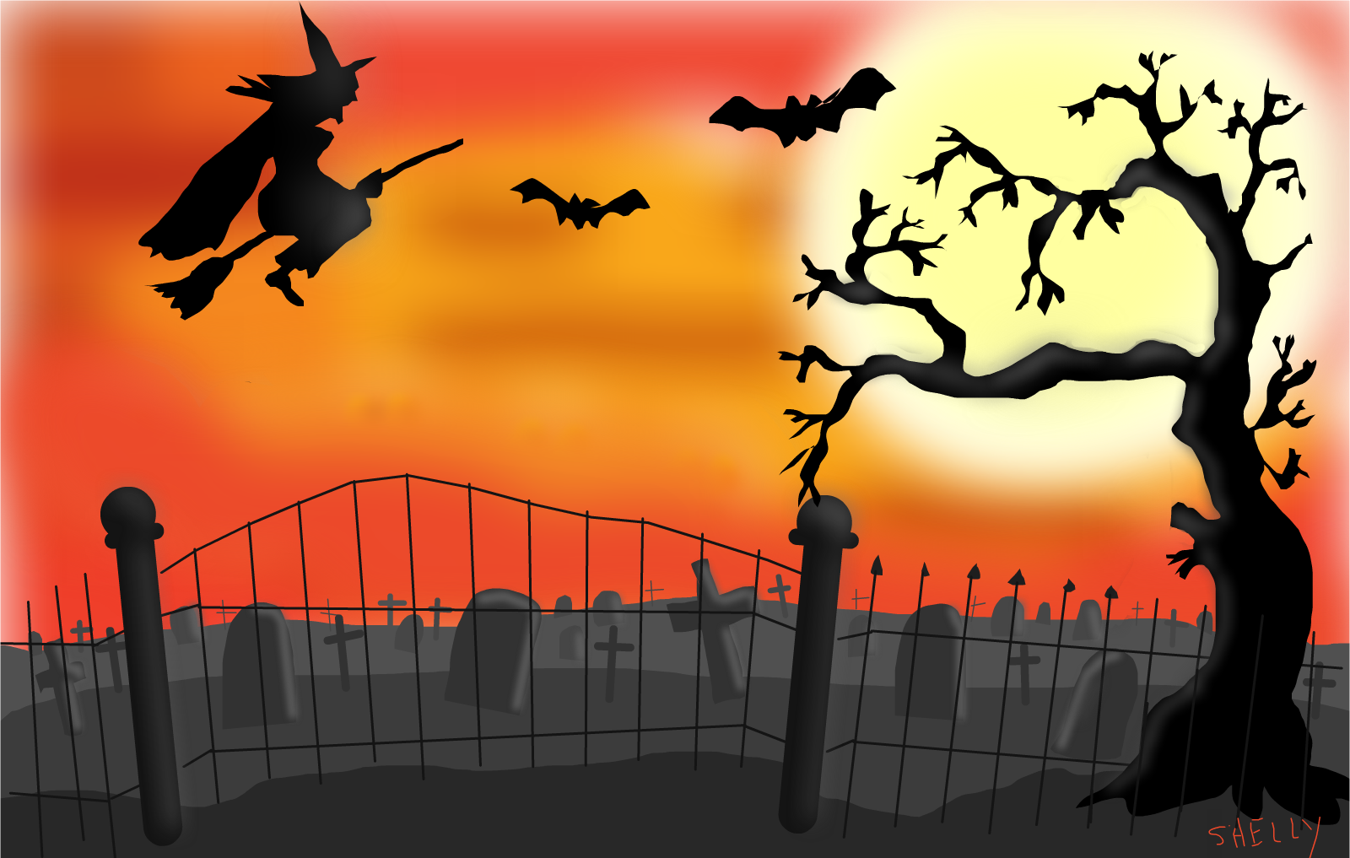

WELSHMOOR EVENTS
SPOOKTASTIC SHOWING SHOW FEATURING FUN CLASS RING
30TH October 2022
World Horse Welfare, Snetterton

Pre - Entries Close: 26th October – Entries Taken on the Day
https://welshmoorevents.lite.events/
Open Welshmoor classes: £13 pre-entry and £15 on the day. Card, cash or PayPal on the day
Fun Classes tickets: £5. On the day entry only (5 classes for £20)
Pre enter and enter more on the day for pre-entry rates.

Welshmoor Rules are Regulations
We aim to run a fun and safe show for all abilities, please read and follow the rules so that everyone can have an enjoyable time
- Stallions may be handled by juniors if they are suitable to do so
- No horse under 4 to be ridden unless stated
- We allow tiny tots in our fun classes, in open classes please make sure riders have obtained their 3rd birthday.
- Pleased keep dogs on a lead and in a controlled manner, Same goes for children apart from the lead (unless you feel they would be better on a lead)
- Please clear up your litter and droppings, keep the show ground clean and tidy.
- Judges give up their time to attend our shows, their decision is final. No abuse at any officials will be tolerated.
- No schooling whips in the ring please
- Any excessive use of whips or spurs on a horse will result in the competitor being asked to leave the ring.
- Please attempt to always keep all horses and ponies under control. Just do your best
- There will be NO class swapping of any kind.
- Refunds will not be given, class vouchers may be offered instead
- Please refrain from taking screen shots of the official photos. Anyone caught doing this who has not paid for said photo, will be restricted from entering any future Welshmoor Event shows.
- Classes will not start before stated on the schedule
- We cannot predict class times, Due to taking entries on the day, we advise you watch your ring accordingly. We are not responsible should you miss your class
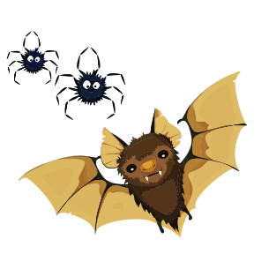
In Hand Classes
Ring 1 (half of the indoor)
Judge – Miss L Calcutt
Ring to Start at 9am.
 | In Hand Novice Pony/horse. Not to have won more than two 1st prizes in any in hand showing before the 1st Jan in the current year. This class is open to all breeds and types. | 8. | In Hand 3 yr old. Any Type
 | In hand Veteran. 15 yrs + open to all breeds. | In Hand Youngstock Championship 1st and 2nd prize winners from classes 5 – 8
 | In Hand Gelding. Any Age, Any Type | 9. | Mountain & Moorland: Open to In Hand Mountain & Moorland ponies of ANY AGE registered with their respective Pure Bred societies Of Welsh A, B, C and D, Dartmoor, Exmoor, Shetland, Fell, Dales, Highland, New Forest, Connemara. Stallion, Mare, Colt, Filly or Gelding
 | In Hand Mare, Any Age, Any Type | 10 | In hand Coloured and Odd Coloured. Piebald, skewbald, Palominos, Duns, Roans, paints, and spots. Open to Horses and ponies of all ages. And all types
In hand ‘Ghost’ championship 1st and 2nd prize winners from classes 1 to 4 |  | 11 | In hand Rare and Foreign Bred of any age. This is also open to Arabs. And Rare and Foreign Part breds. Eg Exmoor, Fell, Suffolk Punch, Shire, Hackney, Cleveland Bay, Halfinger, Andalusian, Trekener, Fresian, Fjord etc
 | In Hand Foal. any type, may be shown with or without their dam | 12 | In Hand Black, Bays, Greys & Chestnut. of any age and height
 | In Hand Yearling, Any Type | 13 | Open In hand, Any age, height and type
 | In Hand 2 yr Old., Any Type | In hand ‘Pumpkin’ championship 1st and 2nd prize winners from classes 9 – 13

A highest placed youngstock rosette will be awarded in all in hand classes except for classes 5 - 8

Fun Class Ring
Ring 2 (half of the indoor)
Judge – The Wicked Witch
Ring to Start at 10am.
14 | Best Turned Out Ridden | 22 | Lorry Dog
15 | Best Turned Out In Hand | 23 | Mums & Dads Class (Mums and Dads welcome to bring the pony in, no show wear required)
16 | Young Handler (Under 16) | championship 1st and 2nd prize winners from classes 19 - 23
17 | Best Up Downs | 24 | Prettiest Mare
18 | Tiny Tots Ridden | 25 | Handsomest Gelding
championship 1st and 2nd prize winners from classes 14 - 18 |  | 26 | Fluffiest Pony
19 | Best Decorated Mane and Tail | 27 | Glitter Award – Best use of glitter on a pony
20 | Best Bottom | championship 1st and 2nd prize winners from classes 24 - 27
21 | My Best Friend | 28 | Fancy Dress
Fun Class Supreme Championship
Open to Champion and Reserve from all Fun Class Championships
1st & 2nd from the Fancy Dress is also eligible

Fun Class Tickets - £5 each or 5 for £20
Welshmoor Events run a ticket method for the fun classes, Simply purchase as many tickets as you wish and hand them in as you go in the ring. No competitor numbers are needed for the fun ring

Ridden Ring
Indoor Arena (Rings 1 & 2 Combined)
Judge – Mrs S Wooderson
Ring to Start not before 12.30
29 | Novice Ridden Horse and Pony. Open to Horses and ponies of 4 yrs. and over. Not to have won more than two 1 st prizes in any Ridden showing before the 1st of Jan in the current year
30 | Lead rein and first ridden. Open to all breeds. First ridden riders 12 years old and under. To be shown in any suitable bridle. Lead to be attached to the noseband. Lead rein riders 9 years old and under. Class will be split if entries warrant.
31 | Walk and Trot. Open to Horses and Ponies of 3 years and over. Open to lead rein and first ridden
‘Vampire’ Ridden class championship. 1st and 2nd prize winners from classes 29 – 31

32 | OPEN RIDDEN MOUNTAIN & MOORLAND BREEDS. Open to Mountain & Moorland ponies registered with their respective Pure-Bred Societies of, Welsh, A, B, C and D, Exmoor, Dartmoor and Shetland, Highland, Fells, Dales, New Forest. Stallion, mare or gelding, 4 years old and over. Rider any age. Lead Rein permitted. Class may be split if entries warrant.
33 | Ridden Coloured and Odd Coloured Horse and Pony. Including Piebald, Skewbald, Duns, Palominos, Roans. Lead rein permitted in this class.
34 | Ridden Bay, Black, Grey and Chestnut. Open to horses and ponies 4 years and over, any height, type, lead rein permitted
35 | Veteran ridden. 15+ years. Open to all breeds including lead rein
36 | Concours D’Elegance Ridden and In hand
Wicked Witch’ Ridden class championship. 1st and 2nd prize winners from classes 32-36
SUPREME OF SHOW
Champion and Reserve placings to compete. Fun Class Section is not Eligible
Deluxe rosettes and sash for both placings

